# Assignment-4

DistanceDetectionUsingUltrasonicSensor

| AssignmentDate | 19October2022 |
| --- | --- |
| StudentName | Jayasathyanarayanan.M |
| StudentRollNumber | 111919106024 |
| MaximumMarks | 2Marks |

# Question-1:

Writecodeandconnectionsinwokwiforultrasonicsensor.Wheneverdistanceislessthan100cmssend"alert"toibmcloudanddisplayindevicerecentevents.

WOKWILINK:https://wokwi.com/projects/345964118720643668

**CODE:**



#include<WiFi.h>//library

forwifi#include<PubSubClient.h>//libraryforMQtt

voidcallback(char*subscribetopic,byte*payload,unsignedintpayloadL

ength);

//-------credentialsofIBMAccounts------

#defineORG"f59trs"//IBMORGANITIONID

#defineDEVICE_TYPE"ultrasonicsensor"//DevicetypementionedinibmwatsonIOTPlatform

#defineDEVICE_ID"distancedetection"//DeviceIDmentionedinibmwatsonIOTPlatform

#defineTOKEN"AlGMGaaF01nawa1QA3"

//TokenStringdata3;floatdist;

//--------Customisetheabovevalues--------

char server[] = ORG

".messaging.internetofthings.ibmcloud.com";//ServerName

charpublishTopic[]="iot-2/evt/Data/fmt/json";//topicnameandtypeofevent perform andformatinwhich datatobesend

charsubscribetopic[]="iot-2/cmd/test/fmt/String";//

cmdREPRESENTcommandtypeANDCOMMANDIS TESTOFFORMATSTRING

charauthMethod[]="use-token-auth";//authenticationmethodchartoken[]=TOKEN;

char clientId[] = "d:" ORG ":" DEVICE_TYPE ":"

DEVICE_ID;//clientid

//

-

WiFiClientwifiClient;//creating theinstanceforwificlient

PubSubClientclient(server,1883,callback,wifiClient);

//calling the predefined client id by passing parameterlikeserverid,portandwificredential

int LED =4;int trig =5;intecho=

18;voidsetup()

{

**Serial**.begin(115200);pinMode(trig,OUTPUT);pinMode(echo,INPUT);pinMode(LED,

OUTPUT);delay(10);wificonnect();mqttconnect();

}

voidloop()//RecursiveFunction

{

digitalWrite(trig,LOW);digitalWrite(trig,HIGH);delayMicroseconds(10);digitalWrite(trig,LOW);

float dur =

pulseIn(echo,HIGH);float dist =(dur * 0.0343)/2;**Serial**.print("Distancein

cm");**Serial**.println(dist);

PublishData(dist);delay(1000);

if (!client.loop())

{mqttconnect();

}

}

/*. retrievingto

Cloud. */

void PublishData(float dist)

{mqttconnect();//functioncallforconnectingtoibm

/*

creating the String in in form JSon to update the datatoibmcloud

*/

Stringobject;

if(dist<100)

{

digitalWrite(LED,HIGH);**Serial**.println("object is

near");object="Near";

}

else

{

digitalWrite(LED,LOW);**Serial**.println("noobjectfound");object="No";

}

String payload =

"{\"distance\":";payload+=dist;payload += ","

"\"object\":\"";payload+=object

;

payload+= "\"}";

**Serial**.print("Sendingpayload:");**Serial**.println(payload);

if(client.publish(publishTopic,(char*)payload.c_str())){

**Serial**.println("Publish ok");// if it sucessfully upload

dataon the cloud then it will print publish ok in Serial monitororelseitwill printpublishfailed

}else{

**Serial**.println("Publishfailed");

}

}

voidmqttconnect(){

if (!client.connected())

{**Serial**.print("Reconnecting client to");**Serial**.println(server);

while(!!!client.connect(clientId,authMethod,token)){

**Serial**.print(".");delay(500);

}

initManagedDevice();

**Serial**.println();

}

}

voidwificonnect()//functiondefinationforwificonnect

{

**Serial**.println();**Serial**.print("Connectingto");

WiFi.begin("Wokwi-GUEST", "", 6);//passing the wificredentialstoestablish theconnection

while (WiFi.status() != WL_CONNECTED)

{delay(500);

**Serial**.print(".");

}

**Serial**.println("");**Serial**.println("WiFi

connected");**Serial**.println("IPaddress:

");**Serial**.println(WiFi.localIP())

;

}

voidinitManagedDevice(){

if (client.subscribe(subscribetopic))

{**Serial**.println((subscribetopic));**Serial**.println("subscribetocmdOK");

}else{

**Serial**.println("subscribetocmdFAILED");

}

}

void callback(char* subscribetopic, byte* payload, unsignedintpayloadLength)

{

**Serial**.print("callbackinvokedfortopic:");**Serial**.println(subscribetopic);

for(inti=0;i<payloadLength;i++){

//Serial.print((char)payload[i]);data3+=(char)payload[i];

}

// Serial.println("data:"+data3);

// if(data3=="Near")

// {

//Serial.println(data3);

//digitalWrite(LED,HIGH);

// }

// else

// {

//Serial.println(data3);

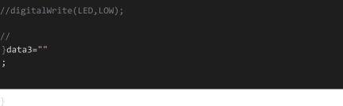

**OUTPUT:**

**Whenobjectisnotneartotheultrasonicsensor**

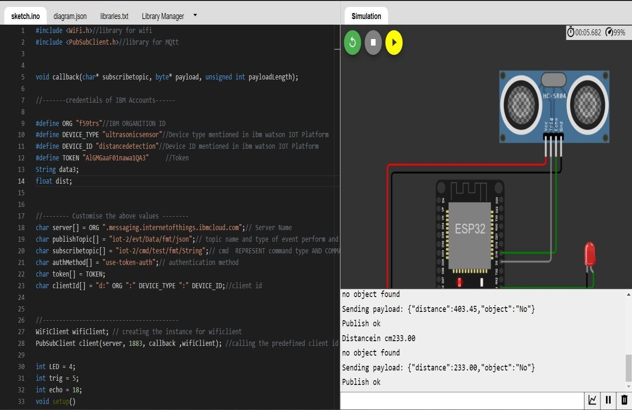

**DatasenttotheIBMclouddevicewhentheobjectisfar**

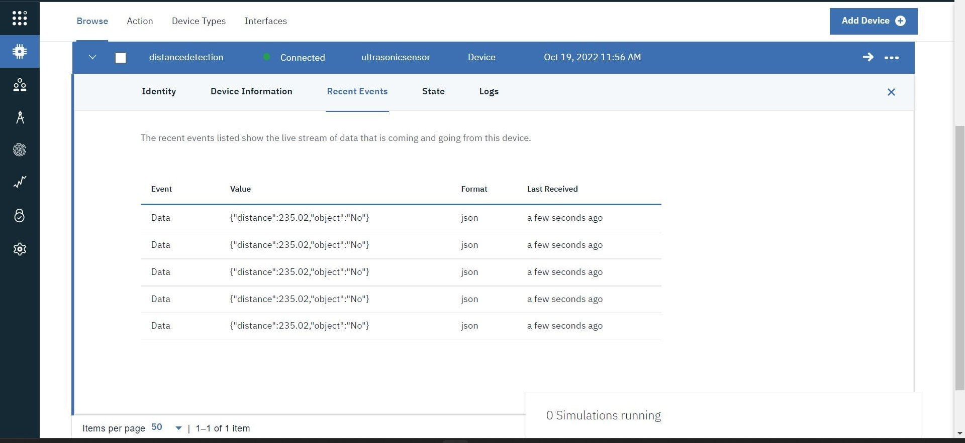

**Whenobjectisnearertotheultrasonicsensor**

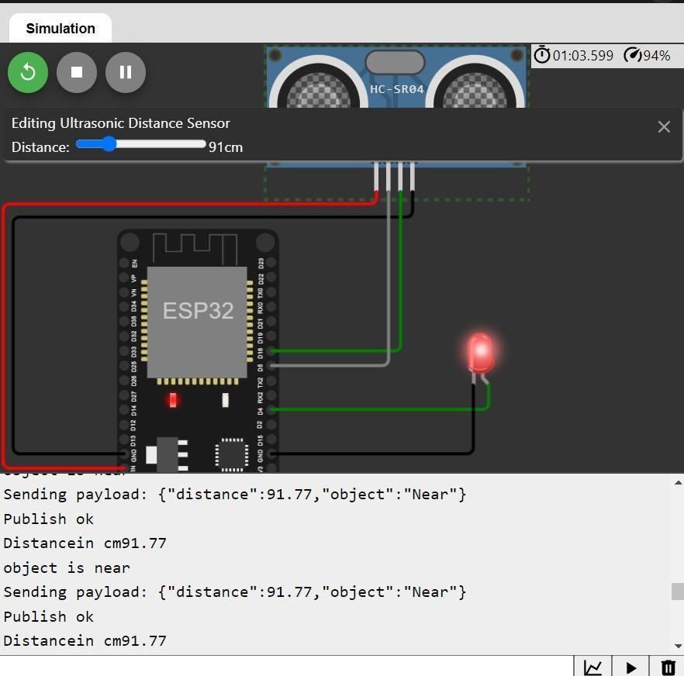

**DatasenttotheIBMclouddevicewhentheobjectisnear**

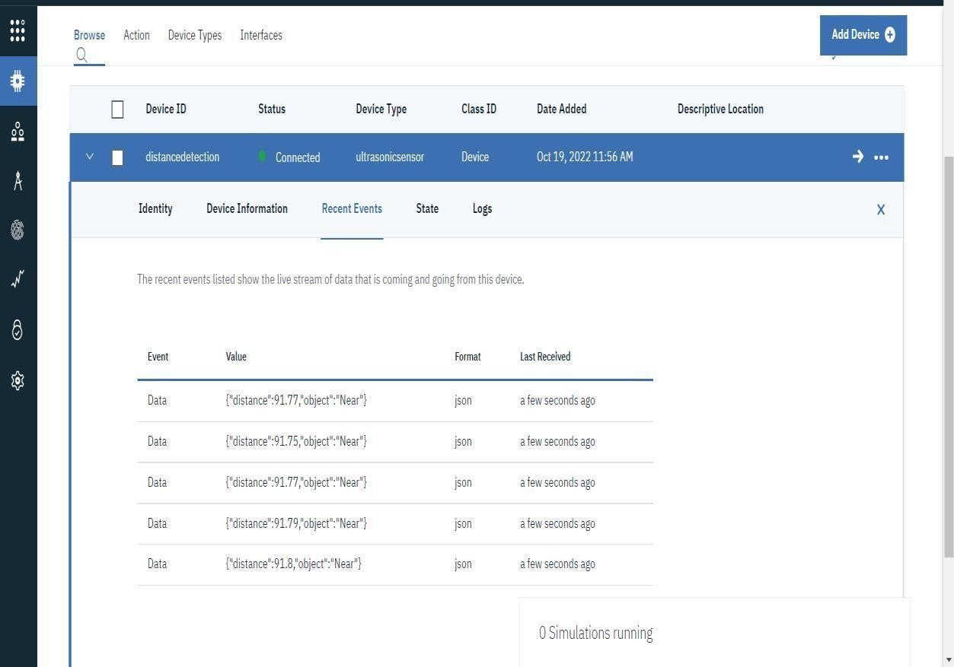

https://wokwi.com/projects/345964118720643668